CS688 G-Trends Lab Project

Yiduo Feng

10/11/2022

Modify the given code for “ Project Functions.R ” to use the time stamp from the “DATE” column to extract the information about the “Hour of Day” and “Day of Week”.

Implement the provided labeling from the “ IIoT Work Study Example 3 – Modified Data ” slides or come up with your own. Training the neural network without the “Hour of Day” and “Day of Week” will result in very bad fit (R-squared≈0)

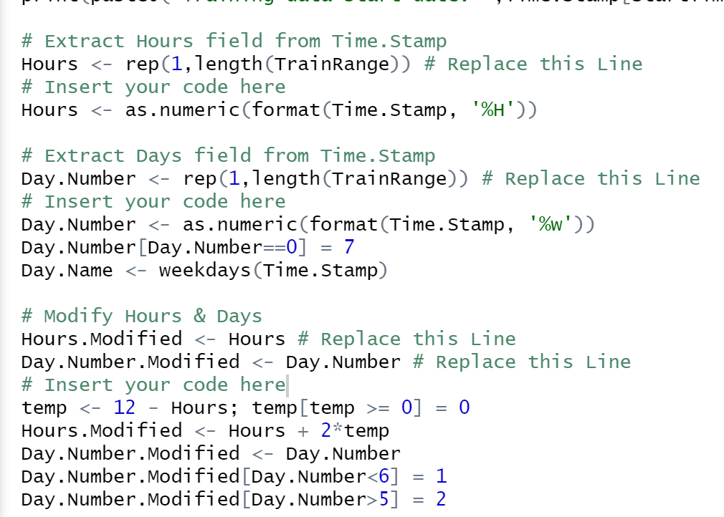

Modify & Optimize your code to get at least R-squared>0.5. 